REPORTS OF TREATMENTS (1)

According 20 years working as a conservator in Ministry of Antiquates of Egypt I have conserve and preserve many kinds of artifacts in different materials some of them as a following:
- Preserve and conserve of Photographic archive of Coptic Museum.
The status of the Coptic Museum's archive album was characterized by severe damage and dehydration due to poor storage in a very dry atmosphere and exposure to physic-chemical factors. This resulted in the album's pages being severely dehydrated and therefore fragile, and easily lost. silver mirroring, which may result in the subsequent loss of image and the presence of color spots and stains resulting from the use of adhesive in the installation of images on the surface gelatin of images and fingerprints, and for the outer shell has resulted in poor storage and handling to the separation of the part The album is worn in the fabric used in the album's packaging, as well as the deterioration of the heel of the album. This may result in the loss of pages from the album with misuse, as well as the presence of wax spots on the outside of the album, which helps adhesion of the macrophages and dust to the surface. In addition to the maintenance and restoration work, a plan of maintenance and restoration has been carried out according to the previous studies and researches published in this field and the results obtained through tests and analyzes of the album and photographs. And detailed pictures of the impact situation before, during and after repairs, documenting all areas of weakness and degradation and separation zones. A digital copy of each image was made to be a source of reference if the images were damaged, The surface of the soil using soft brushes and then the use of alcohol and water in the removal of wax spots, and then strengthen the weak places, and complete the missing parts, and then re-binding of the album and processing in the museum exhibition.
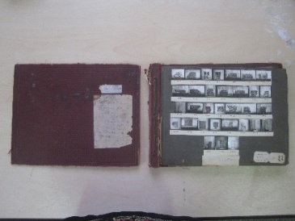 | 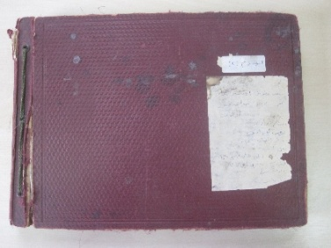 | 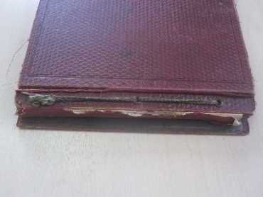 | 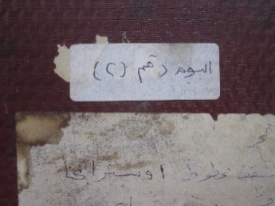
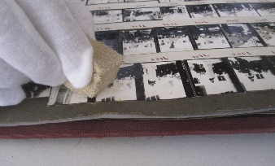 | 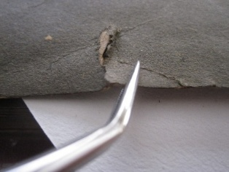 | 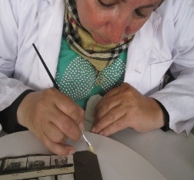 | 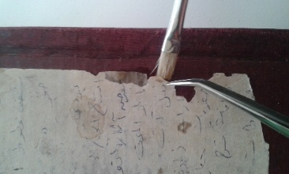
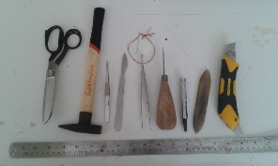 | 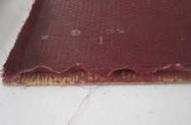 | 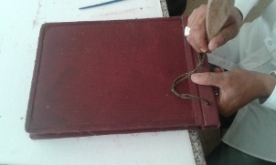 | 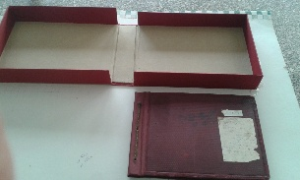
Figures show treatment steps to preserve and conserve Coptiv Museum Archive

REPORT OF TREATMENT (2)
According to may study in Egyptian Italian Center for Conservation of Antique Photographs and Heritage Paper (EICAP) I have finished documenting, digitalizing, and preserving The album of Ismail Pasha, it is located in Royal Vehicles Museum, Cairo, Egypt. The museum includes five albums of photographs, it has been selected one of these albums to be practical side of the study, dated from the 19th century. The album contented of 85 pages, each page has one photo, all the photos are Albumen Silver Print, which is recorded and documented special services vehicles of Khedive Ismail. Some of them one shoot and some others have been taken in two phases and were assembled in one piece due to the large size of the vehicle, on the face of the album there is the royal emblem doctrine has put, as well the name of the photographer on the cover from the outside, all of which are coated with red leather from the outside, and made with excellent manner, good condition.
Documentation of the album
- Object Identification Data |  | - Archeological Data |  |  |  | - Description  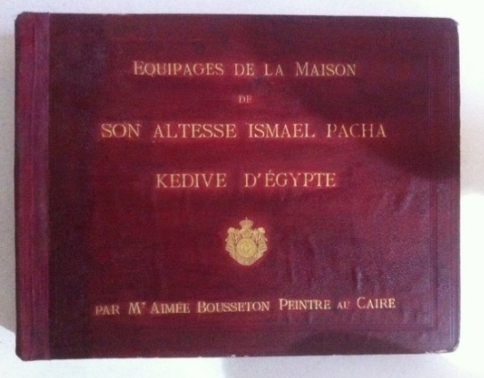
Object No. | 4 ي | period | Ottoman Empire
 |  | century | 19th Century
 |  | artist | Aimée Bousseton
 |  | provenance | Manial Palace
 |  | Owner | Khedive Ismail
Other No. | 404 | place | Vehicles Museum
 |  | - Dimensions
It is housed in Royal Vehicles Museum, Ministry of Archeology. |  | length |  | width | thickness | Material: Albumin photographic prints.
 |  | 58 cm |  | 47 cm | 7 cm

These some pages of the album containing Black and White Silver Albumin Photographs:

[Album of the Crews of the house of His Highness the Khedive of Egypt]
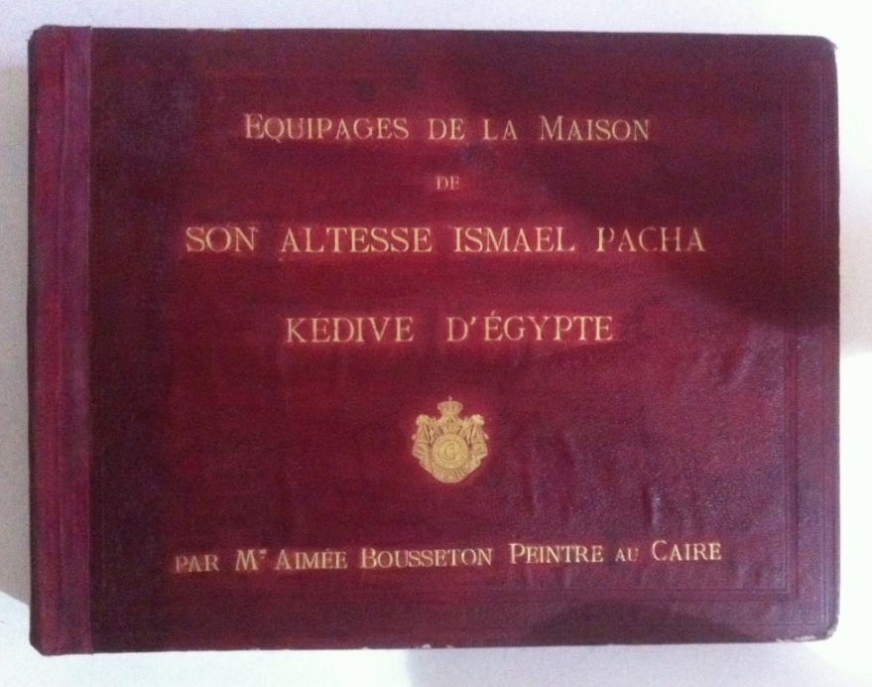
Object Details
Title:
[album of the Crews of the house of His Highness the Khedive of Egypt]
Artist/Maker:
Aimée Bousseton
Owner:
Khedive Ismail
Model:
Equipages de la Maison de son Altesse Ismael Pachs Kedive d’Égypt
Place:
Egypt (Royal Vehicles Museum)
Period:
Ottoman Empire (19th Century)
Date:
1860s
Medium
Albumen silver print
Page No.:
85 pages
Dimensions:
58 cm x 47 cm x 7 cm
Object Type:
Album
Object Number:
4 ي (404)

[Portrait album of the Crews of the house of His Highness the Khedive of Egypt]
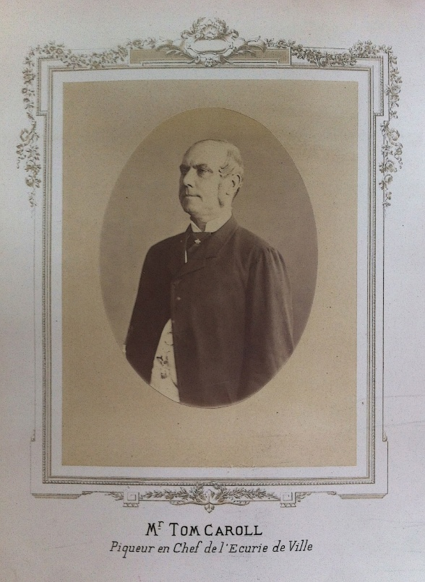
Object Details
Title:
[Portrait album of the Crews of the house of His Highness the Khedive of Egypt]
Artist/Maker:
Aimée Bousseton
Owner:
Khedive Ismail
Model:
Mr. Tom Caroll (Headman of the City Stable)
Place:
Egypt (Vehicles Museum)
Period:
Ottoman Empire (19th Century)
Date:
1860s
Medium
Albumen silver print
Page No.:
62
Dimensions:
25.3 cm x 15.3 cm
Object Type:
Album
Object Number:
4 ي (404)

[Coupi of Post album of the Crews of the house of His Highness the Khedive of Egypt]

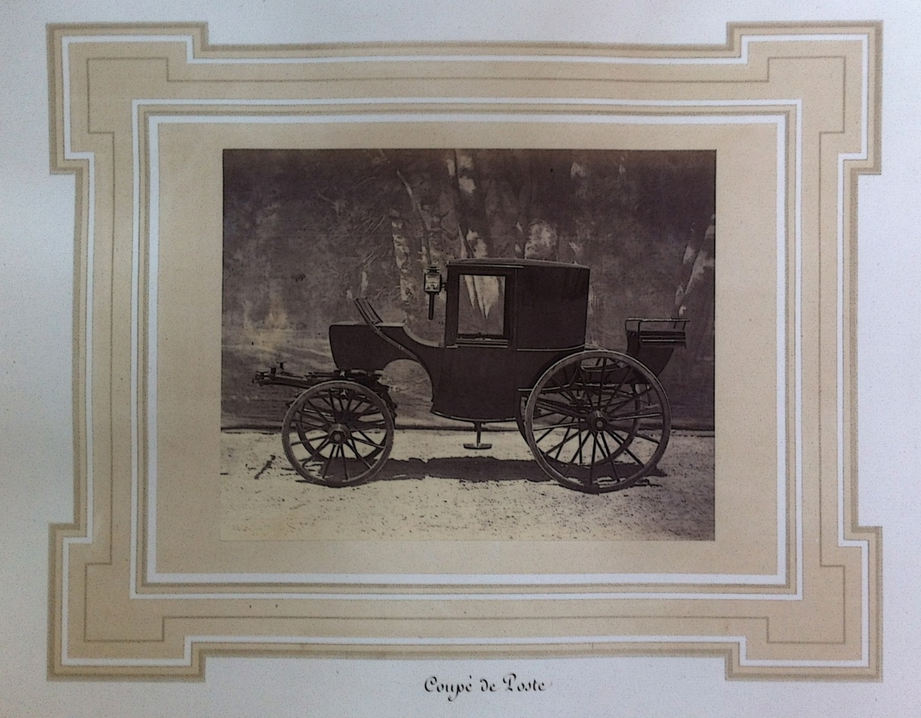
Object Details
Title:
[Coupi of Post album of the Crews of the house of His Highness the Khedive of Egypt]
Artist/Maker:
Aimée Bousseton
Owner:
Khedive Ismail
Model:
Coupi de Post
Place:
Egypt (Royal Vehicles Museum)
Period:
Ottoman Empire (19th Century)
Date:
1860s
Medium
Albumen silver print
Page No.:
67
Dimensions:
25.3 cm x 15.3 cm
Object Type:
Album
Object Number:
4 ي (404)

[Caléche of Post album of the Crews of the house of His Highness the Khedive of Egypt]
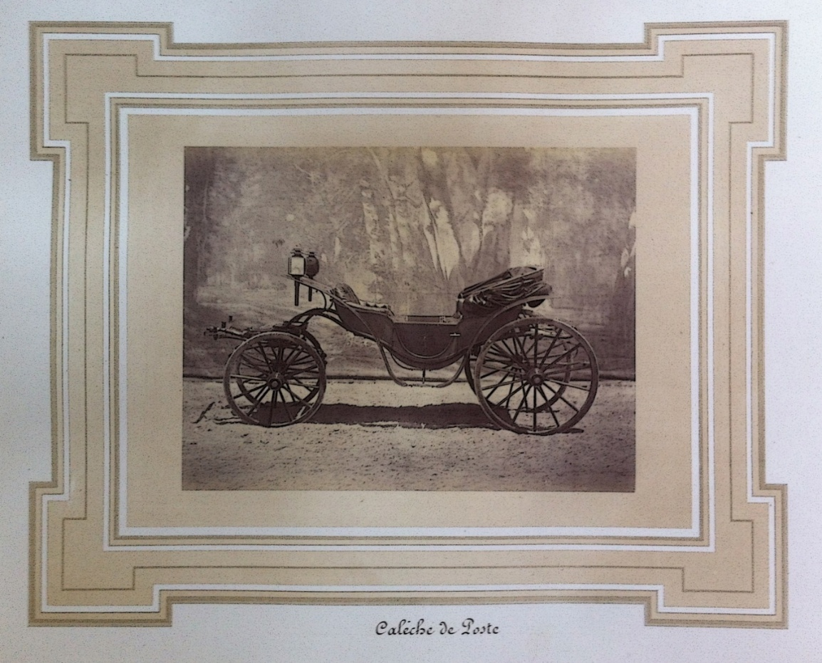
Object Details
Title:
[Caléche of Post album of the Crews of the house of His Highness the Khedive of Egypt]
Artist/Maker:
Aimée Bousseton
Owner:
Khedive Ismail
Model:
Caléche de Poste
Place:
Egypt (Royal Vehicles Museum)
Period:
Ottoman Empire (19th Century)
Date:
1860s
Medium
Albumen silver print
Page No.:
69
Dimensions:
25.3 cm x 15.3 cm
Object Type:
Album
Object Number:
4 ي (404)
[Due de Poste, album of the Crews of the house of His Highness the Khedive of Egypt]
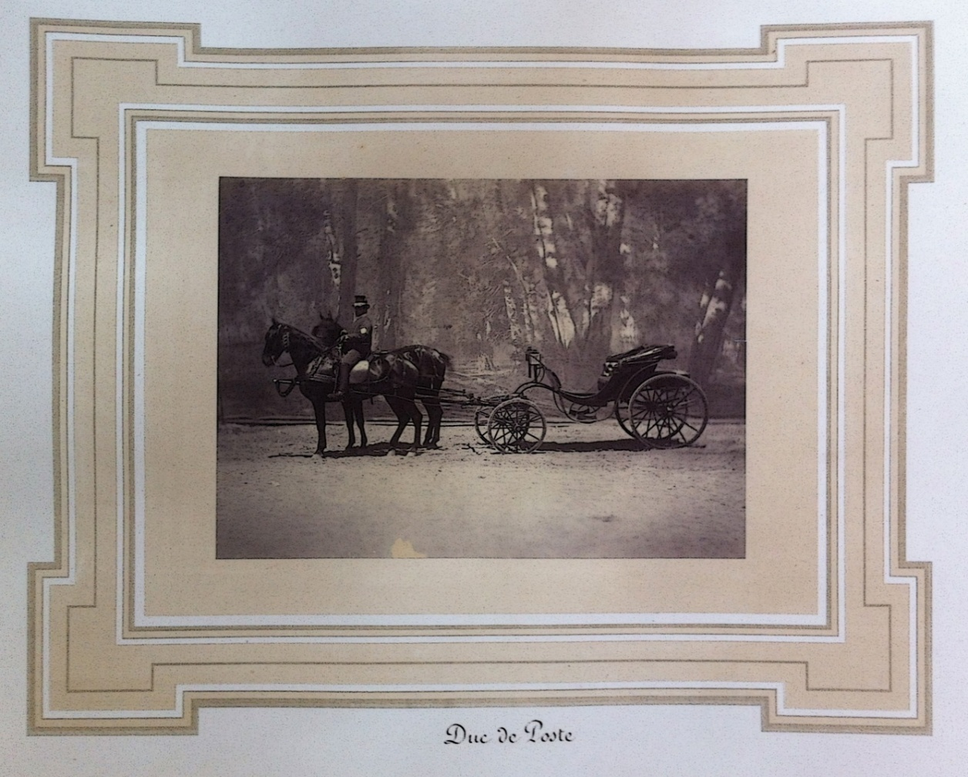
Object Details
Title:
[Due de Poste, album of the Crews of the house of His Highness the Khedive of Egypt]
Artist/Maker:
Aimée Bousseton
Owner:
Khedive Ismail
Model:
Due de Poste
Place:
Egypt (Royal Vehicles Museum)
Period:
Ottoman Empire (19th Century)
Date:
1860s
Medium
Albumen silver print
Page No.:
70
Dimensions:
25.3 cm x 15.3 cm
Object Type:
Album
Object Number:
4 ي (404)
[Char à Bancs album of the Crews of the house of His Highness the Khedive of Egypt]
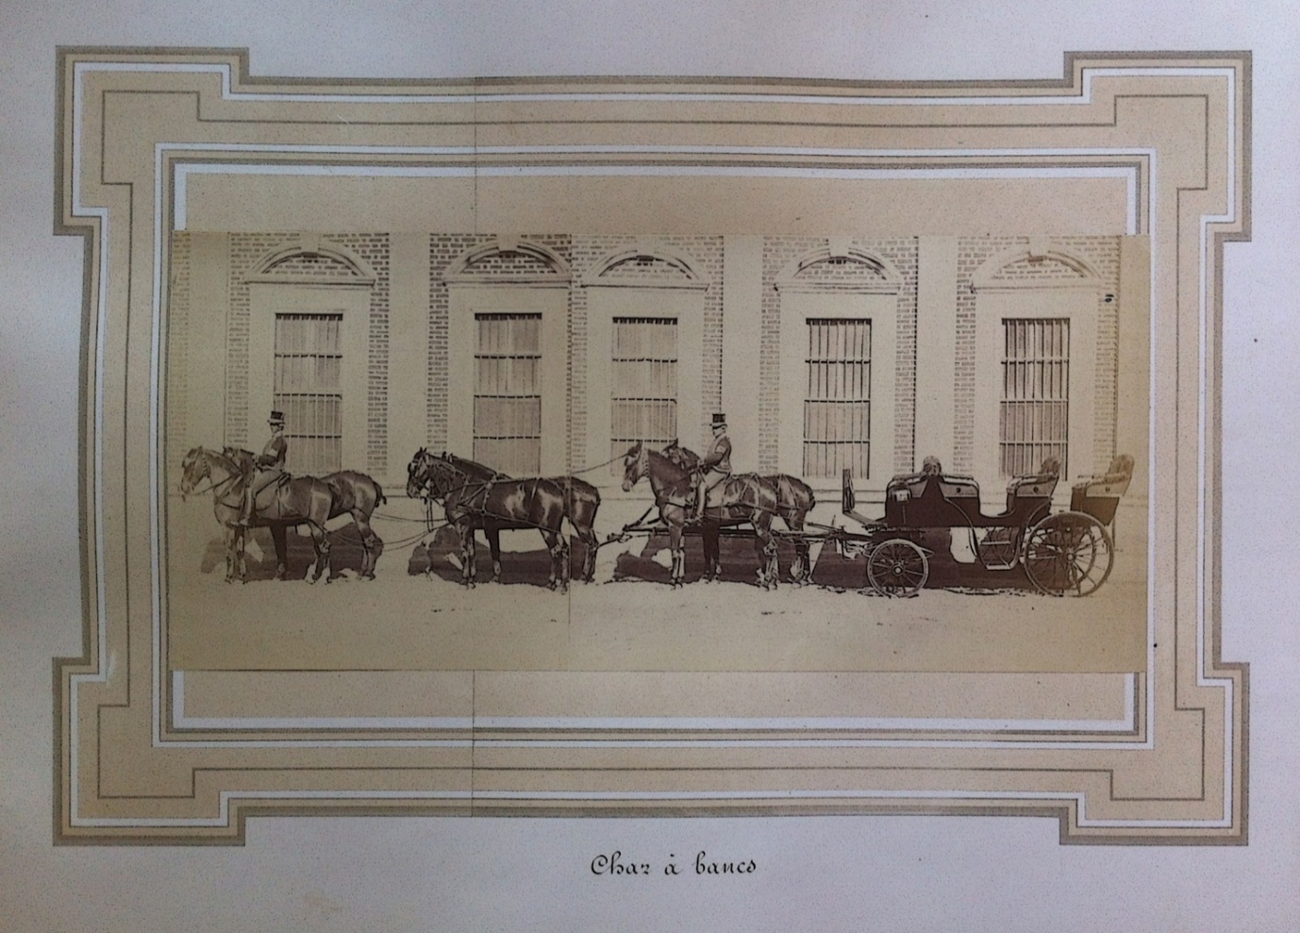
Object Details
Title:
[Char à Bancs album of the Crews of the house of His Highness the Khedive of Egypt]
Artist/Maker:
Aimée Bousseton
Owner:
Khedive Ismail
Model:
Char à Bancs
Place:
Egypt (Royal Vehicles Museum)
Period:
Ottoman Empire (19th Century)
Date:
1860s
Medium
Albumen silver print
Page No.:
72
Dimensions:
32.3 cm x 15.3 cm
Object Type:
Album
Object Number:
4 ي (404)

[Voyageuse, album of the Crews of the house of His Highness the Khedive of Egypt]
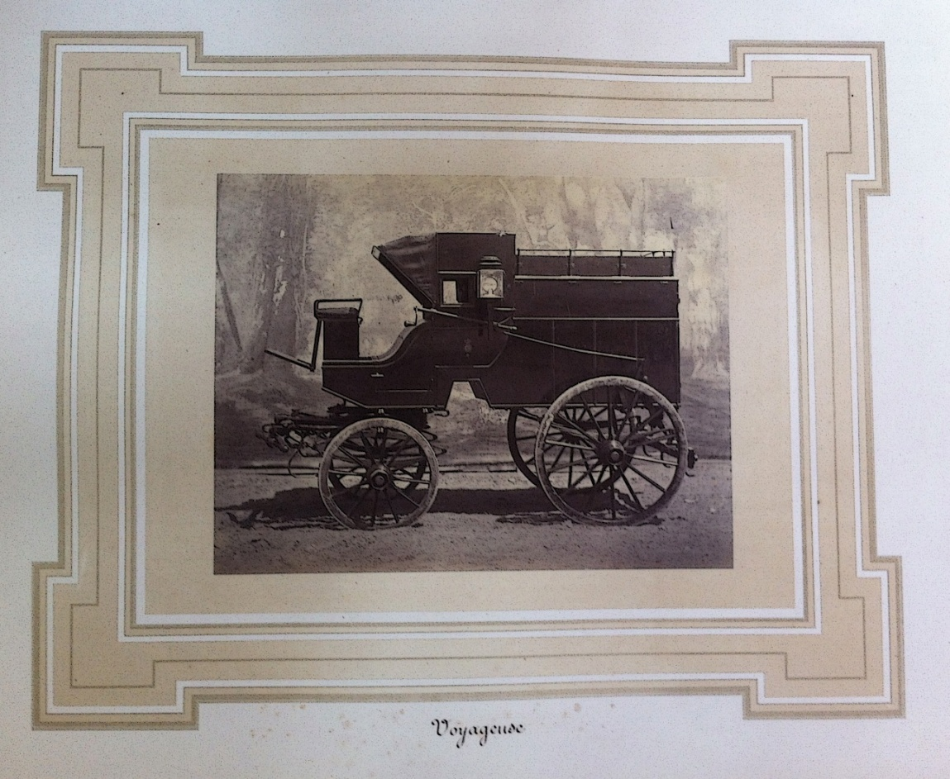
Object Details
Title:
[Voyageuse, album of the Crews of the house of His Highness the Khedive of Egypt]
Artist/Maker:
Aimée Bousseton
Owner:
Khedive Ismail
Model:
Voyageuse
Place:
Egypt (Royal Vehicles Museum)
Period:
Ottoman Empire (19th Century)
Date:
1860s
Medium
Albumen silver print
Page No.:
78
Dimensions:
25.3 cm x 15.3 cm
Object Type:
Album
Object Number:
4 ي (404)

[Caravane, album of the Crews of the house of His Highness the Khedive of Egypt]
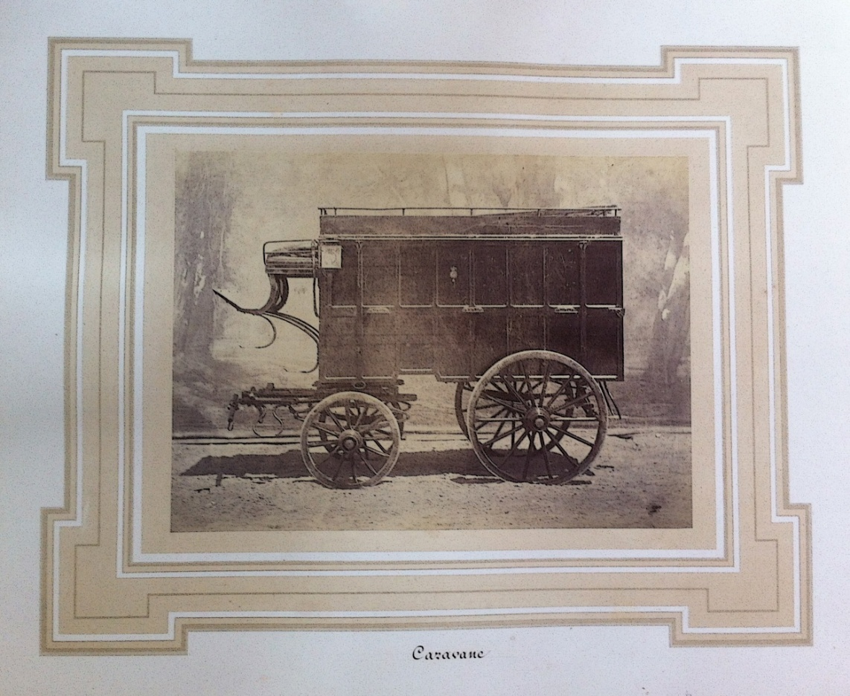
Object Details
Title:
[Caravane, album of the Crews of the house of His Highness the Khedive of Egypt]
Artist/Maker:
Aimée Bousseton
Owner:
Khedive Ismail
Model:
Caravane
Place:
Egypt (Royal Vehicles Museum)
Period:
Ottoman Empire (19th Century)
Date:
1860s
Medium
Albumen silver print
Page No.:
80
Dimensions:
25.3 cm x 15.3 cm
Object Type:
Album
Object Number:
4 ي (404)

Portrait album of the Crews of the house of His Highness the Khedive of Egypt]
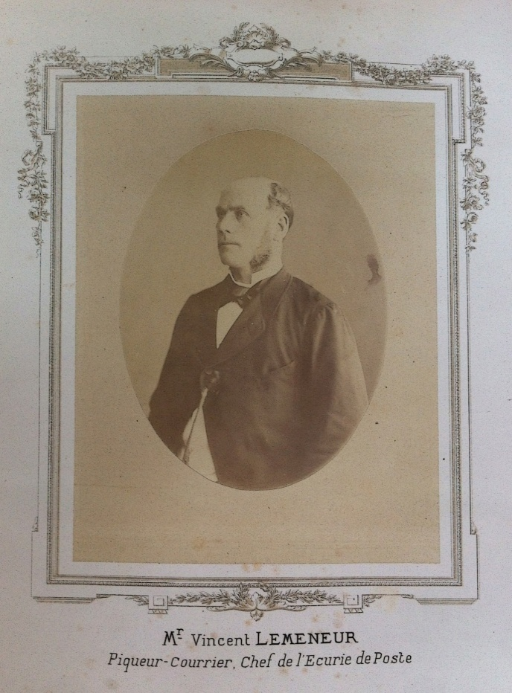
Object Details
Title:
[Portrait, album of the Crews of the house of His Highness the Khedive of Egypt]
Artist/Maker:
Aimée Bousseton
Owner:
Khedive Ismail
Model:
Mr. Vincent Lemeneur (Piqueur-Courrier, Chef de l’Ecurie de Poste)
Place:
Egypt (Royal Vehicles Museum)
Period:
Ottoman Empire (19th Century)
Date:
1860s
Medium
Albumen silver print
Page No.:
52
Dimensions:
25.3 cm x 15.3 cm
Object Type:
Album
Object Number:
4 ي (404)
[Estafette, album of the Crews of the house of His Highness the Khedive of Egypt]
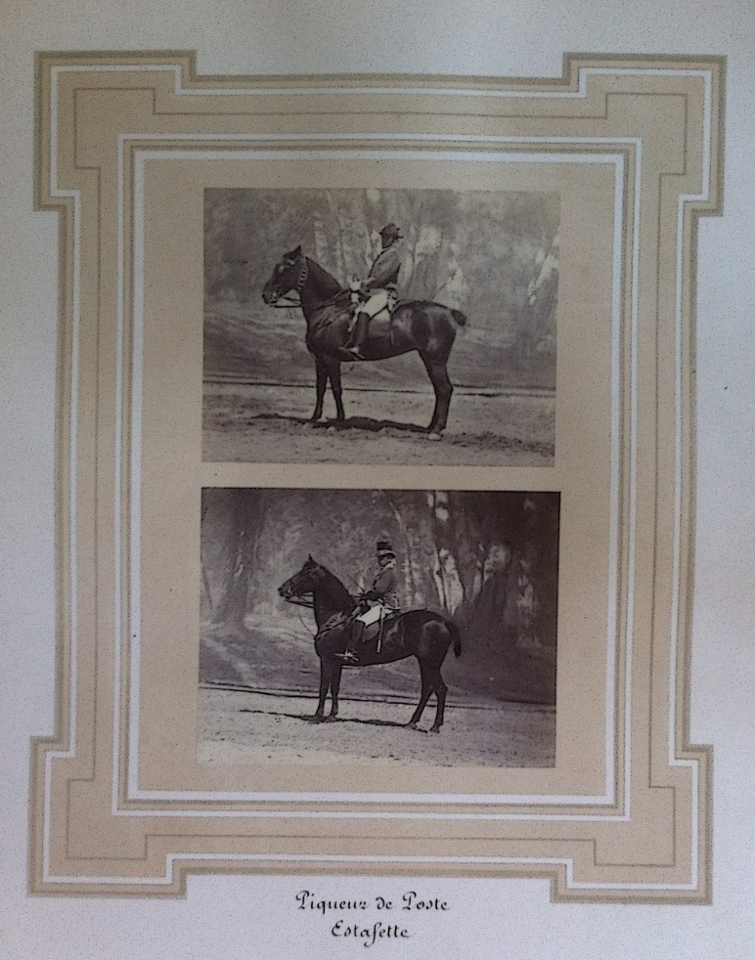
Object Details
Title:
[Estafette, album of the Crews of the house of His Highness the Khedive of Egypt]
Artist/Maker:
Aimée Bousseton
Owner:
Khedive Ismail
Model:
Piqueur de Poste - Estafette
Place:
Egypt (Royal Vehicles Museum)
Period:
Ottoman Empire (19th Century)
Date:
1860s
Medium
Albumen silver print
Page No.:
82
Dimensions:
32.3 cm x 15.3 cm
Object Type:
Album
Object Number:
4 ي (404)
[Costume of Post, album of the Crews of the house of His Highness the Khedive of Egypt]
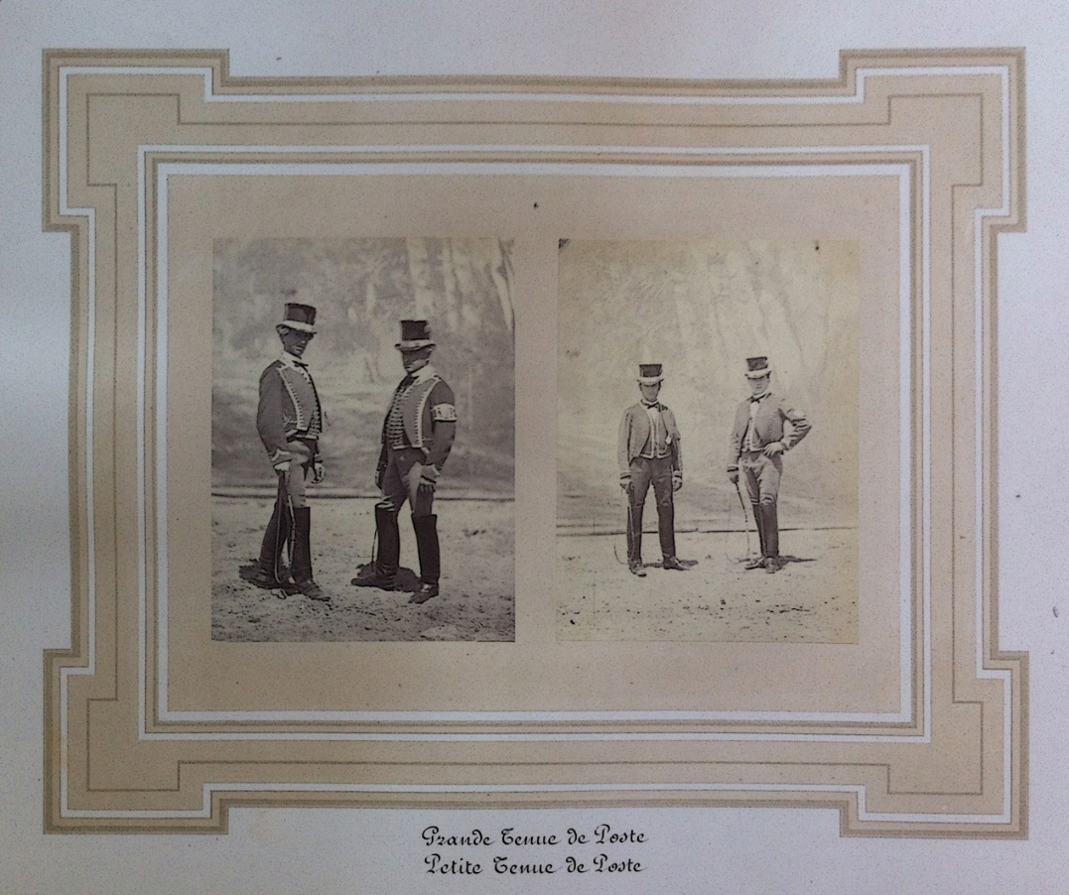
Object Details
Title:
[Costume of Post, album of the Crews of the house of His Highness the Khedive of Egypt]
Artist/Maker:
Aimée Bousseton
Owner:
Khedive Ismail
Model:
Grande Tenue de Poste & Petite Tenue de Poste
Place:
Egypt (Royal Vehicles Museum)
Period:
Ottoman Empire (19th Century)
Date:
1860s
Medium
Albumen silver print
Page No.:
83
Dimensions:
32.3 cm x 15.3 cm
Object Type:
Album
Object Number:
4 ي (404)

[Landau, album of the Crews of the house of His Highness the Khedive of Egypt]
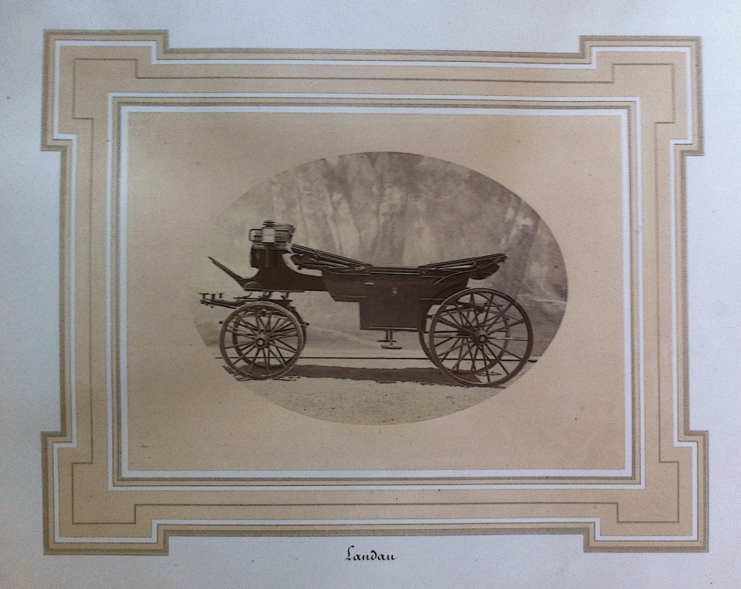
Object Details
Title:
[Landau, album of the Crews of the house of His Highness the Khedive of Egypt]
Artist/Maker:
Aimée Bousseton
Owner:
Khedive Ismail
Model:
Landau
Place:
Egypt (Royal Vehicles Museum)
Period:
Ottoman Empire (19th Century)
Date:
1860s
Medium
Albumen silver print
Page No.:
4
Dimensions:
25.3 cm x 15.3 cm
Object Type:
Album
Object Number:
4 ي (404)

Deterioration aspect of Royal Album and the albumin photos
category | Deterioration aspects | place | image
Discoloring | Change of color in lather used in packaging as a result of oxidation processes | The cover | 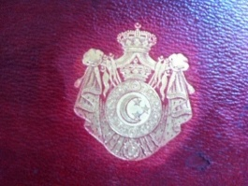
Fading | Fade in color casing used in packaging | The cover | 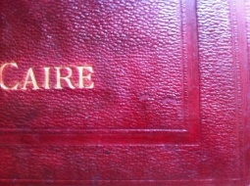
Splits | Separation and flake in the surface layer of the lather is used in packaging | The cover | 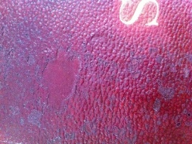
Previous conservation | Old textile and adhesive material had been used to reduce the movement between the pages. | The cover | 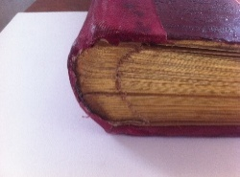
Weakness in edges | Flake, and weakness in the edges of the cover | The cover | 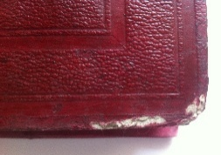
Impact of the Iron ink on paper | The spread of acid found in the Iron ink corresponding page | First page | 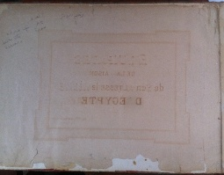
Microbiology stains | Brown spots as a result to biological damage | Page 52 | 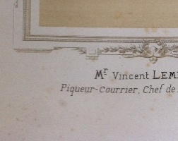
stains | Water stains on the edges of papers | Some papers | 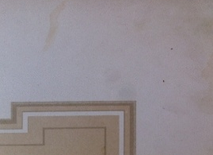
Stains | Rust spots | First page | 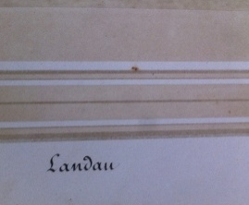

Preservation processes of Royal album and photos
category | Preservation processes | place | image
Mechanical Cleaning | Clean pages of dust using a soft brush with the use of cotton gloves | Albumin photos | 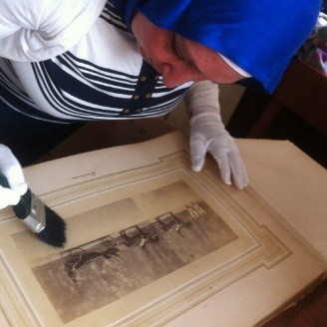
Mechanical Cleaning | Clean the joint between the pages with soft brush | The pages | 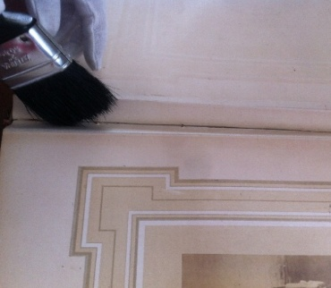
Cuttings treatment | Cuttings were installed treatment by using the adhesive Carboxy methyl Cellulose | Page 68 | 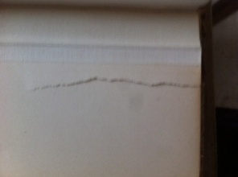
Control in the surrounding environmental conditions | Measure both temperature, relative humidity , light intensity, UV using the Data Lugar device | The album | 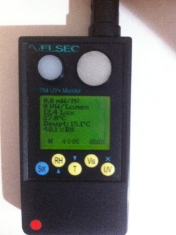
Chemical Cleaning | Clean the stains using alcohol with water 5%. | The pages | 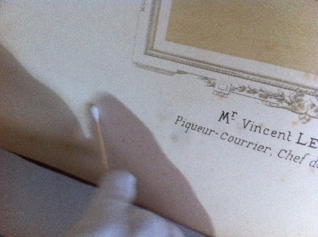
Chemical Cleaning | Clean the stains on the lather surface using alcohol with water 5%. | The cover | 